**ONLINE COURSE FOR YOUTH SPORT COACHES**

Course: **Double-Goal Coach: Coaching for Winning and Life Lessons**

Coupon Code: **WebsterSoftball25**

1. Go to [PCA's Online Course Page](https://cw3gm04.na1.hs-sales-engage.com/Ctc/I6+23284/cW3GM04/Jks2-6qcW69sMD-6lZ3lfN3C47Dn-t2qvW4bCCyC1Jtq1bW4d0qgp6_QppjW1B0Knf8QRKsWW61Y32b1NYVRLVQl5DZ7YBhYqW4wYhrZ3vXCPFW86-jYf7-19r-W1YlFNX58X4dXW1D6KZD2gCGlZW1VNftz4nfMfrW6B92xq5MnngpW8VyL-F6hPpl5W2kYKVy2Gq2ttW85rhmY4QJcFmW1lrz065Wfw22W61YP-M2xqtlXW40MSw06N6gbBW2ZgX2322y0RMN4J_pVWYSs7Qf8cFSB204)

2. Click Login (Located at the top right corner of the page), then click Sign Up.

3. Fill out the registration form and click Sign Up.

4. Once registered/signed in, you will be taken to your PCA Online Course Dashboard: Scroll down a little to the catalog – It should be the second course listed from the left

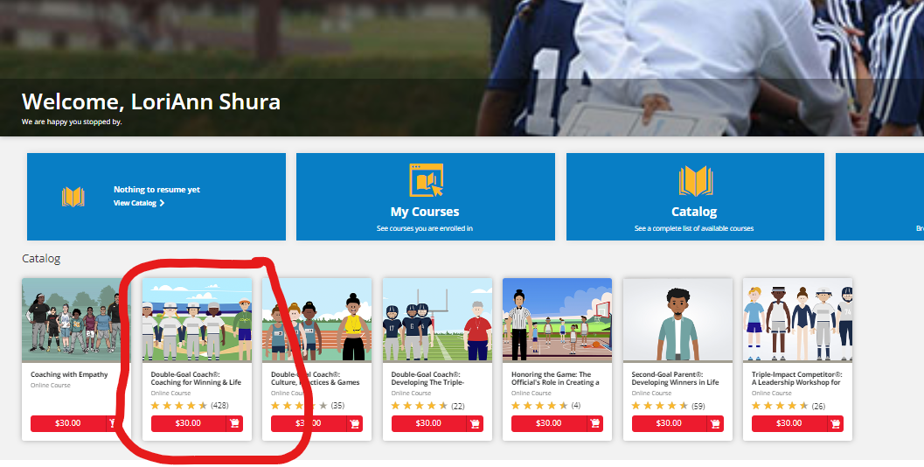

5. Visit the Catalog at the bottom of the page, and click the **$30.00 – Add to Cart** button underneath the **"Double-Goal Coach: Coaching for Winning and Life Lessons"** course.

6. In the upper right corner, click the shopping cart icon and **View Shopping Cart.**

7. After confirming you’ve selected the correct course, Enter your Coupon Code (**WebsterSoftball25**) and click **Apply** and once discount is applied, click **Proceed to Checkout**

8. Complete the shipping information (required) and click on **View Course** to begin!